User Manual
How to change a file’s security policy



Changing the Security Policy in Outlook Add-in

The security policy assigned to each file determines how recipients will access and use the data.
Shared files are automatically secured by the Default security policy, which is the basic policy.
In order to enhance the level of security, you can change the security policy according to the file’s classification by selecting the appropriate policy from the dropdown menu.
Alternatively, you can keep the Default policy set by the system admin.
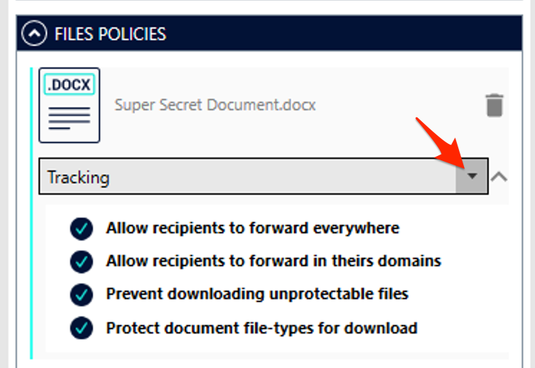

That’s it! You can now compose your email and send it, knowing our attachments are secure.

Changing the Security Policy of a shared file

In the My Files module, right-click the file you have previously shared and select “Security settings” from the menu.

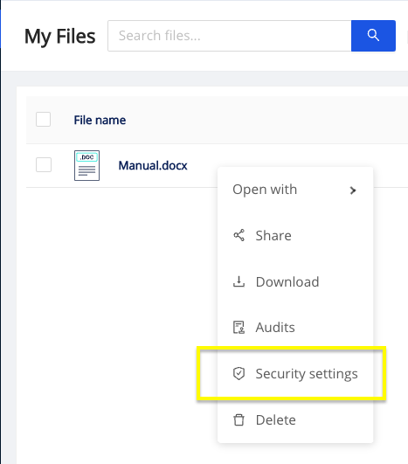

Select “Domain Forwarding” from the dropdown menu and click Apply.

